Copy update, 26th Sept

1. HOMEPAGE

Text block above WTP title:

Britain in 2026 is in crisis.
We The People is a vision of how we can change
our fortunes – and our future – together.
The task is enormous.
This is how it begins
OR It begins here.

Front page, text blocks:

OUR REAL PROBLEM
We all have opinions on what needs to be done.
But there is a deeper threat which
almost no-one is trying to fix.

OUR REAL HOPE
Both ancient and new, a practical plan
for how we overcome our divisions
and start to turn things around.

BE PART OF IT
Here are ways to help make it happen
by yourself, in your community
and for our country.

2. OUR REAL PROBLEM, MAIN PAGE

[IMAGES: UK DECAY, URBAN WASTELAND, DEFEATED PERSON, DESTITUTION, RUBBISH]

FROM DECK (hard to license)
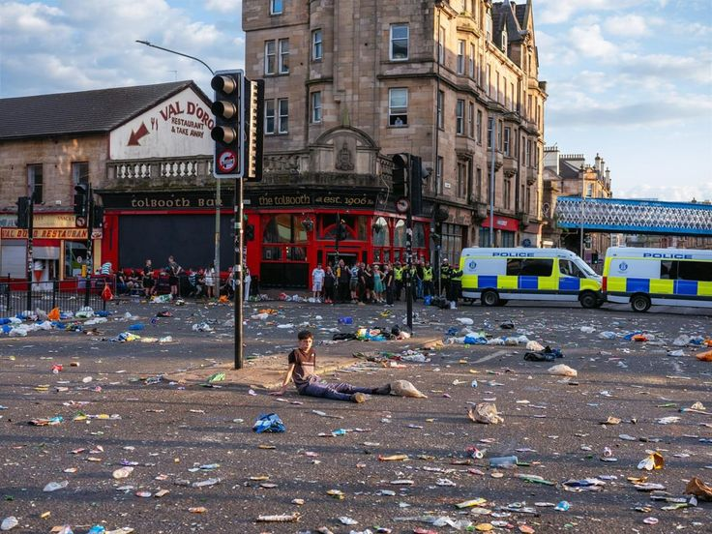

WE ALL KNOW THINGS ARE GOING WRONG.
WE ALL FEEL IT.

Like you, everyone has their own list: cost of living, inequality, immigration, the march to war, the climate, the water, the trains, even potholes...

Whatever we care about, effective action is so rarely taken.

And we’re left feeling disillusioned, angry, afraid and powerless above all.

[GLOOMY FOREBODING DARK HOUSES OF PARLIAMENT]

From deck:
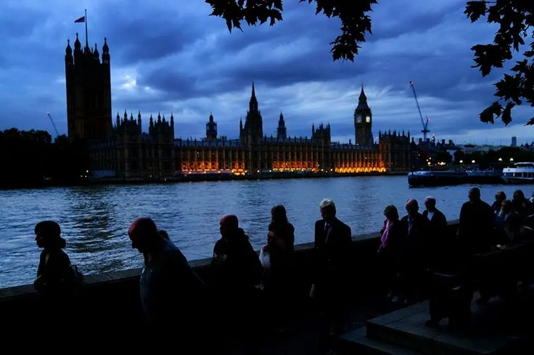

THE OLD WAY
OF ENTRUSTING POLITICIANS
ISN’T WORKING

It’s not clear if any politicians put our interests first – or even if they could, given the swamp of bureaucracy, finance and pressures of the global system with which they contend.

The promise of elections tells us that if things are going wrong, we can elect someone different, someone better.
Yet how often have we voted with high hopes, only to be let down?

No wonder trust in politicians is the lowest it’s ever been.

And more and more people are losing faith in the system itself.

[PROTESTS OF PEOPLE SHOUTING, FLAGS, ANTIFASCISTS VS PATRIOTS, RIOT POLICE, STREET SCUFFLES]

Eg. 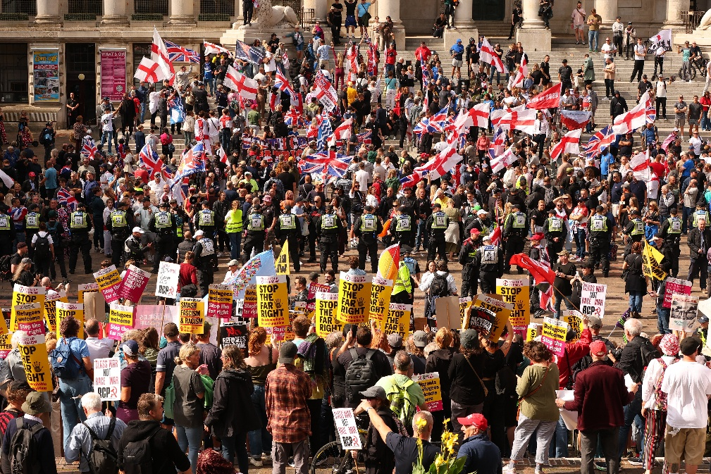

OUR REAL DANGER

Plenty of people think this is just an efficiency problem.

If politicians delivered, and things worked better, then everything would go back to normal.

But something deeper and far more dangerous stands in the way.

WE ARE BECOMING TRIBAL

A perfect storm of social alienation, economic pressure, social and partisan media, is driving us deeply apart.

Politicians don’t help. Most pitch to one tribe or other in their quest for power.

Our current system of democracy is not designed for this.

Our elections rely on the losers accepting defeat.

But in a tribal society, it is highly unlikely that one side will consent to the rule of the other.

This kind of division has ushered in dictatorships or even led to civil war in other places, at other times.

[IMAM & FAR RIGHT GUY HUGGING, SHAKING HANDS; PEACE ACROSS THE LINES/DIVIDE; BLACK GUY CARRYING WHITE PROTESTOR]

From deck:
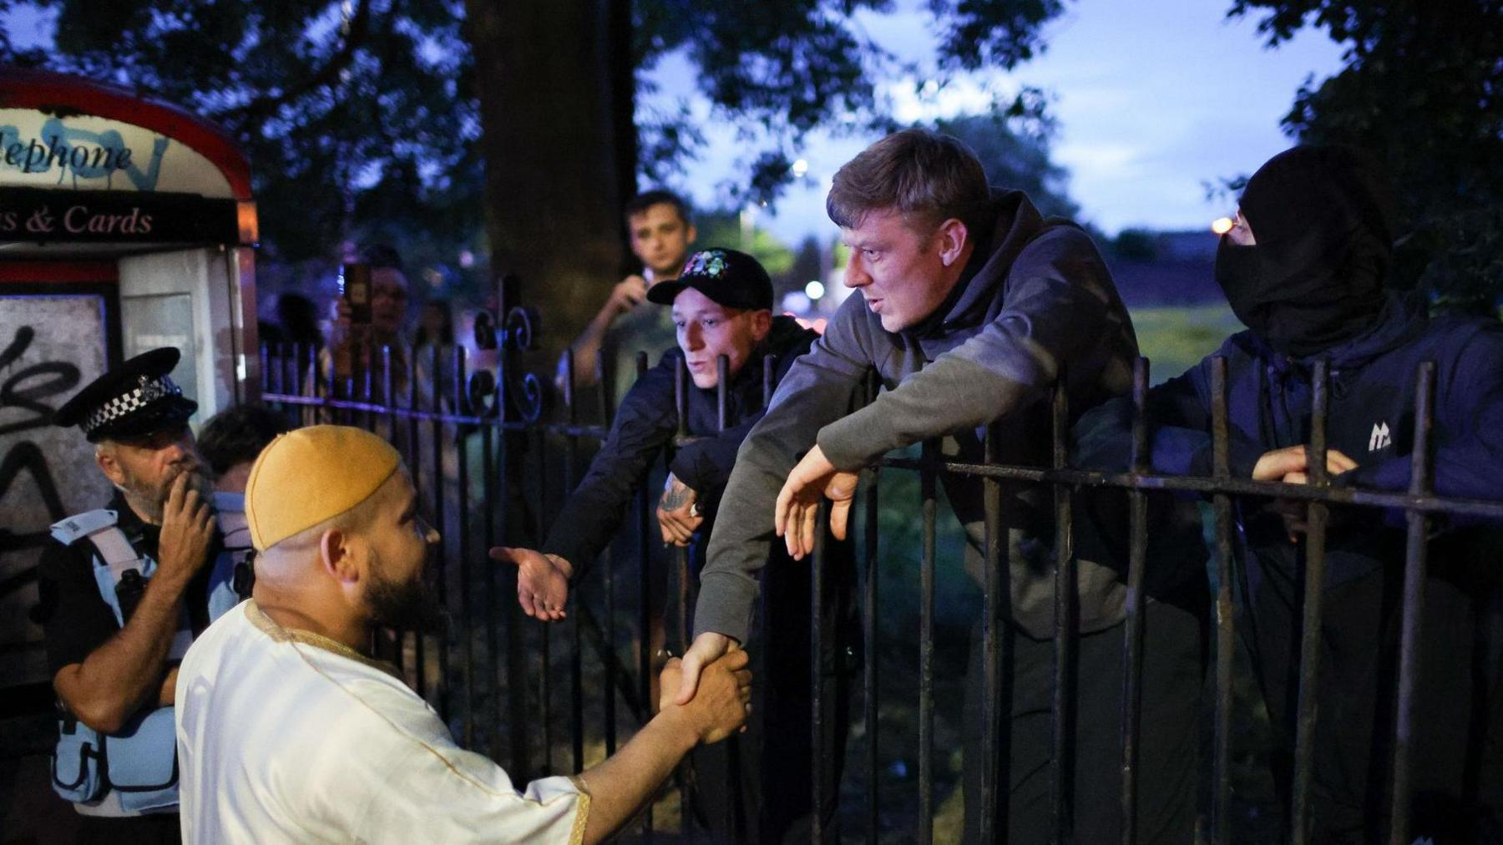

BUT WE THE PEOPLE STILL BELIEVE IN DEMOCRACY.

We believe we can rediscover our ability to talk, listen and compromise no matter how difficult it seems right now.

It will not happen through politicians, political parties or elections.

We need something new.

THAT IS WHAT THIS PROJECT IS ALL ABOUT.

OUR REAL HOPE, MAIN PAGE

We believe the work starts with the issue that most urgently threatens our collective life.

[BOATS; LIFEJACKETS; WHITE CLIFFS OF DOVER]
From deck:
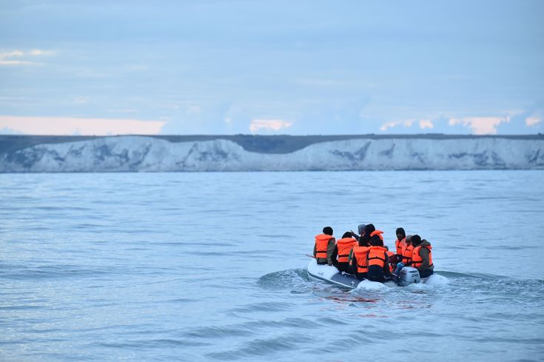

IMMIGRATION

On nothing else are our divisions as deep or as dangerous.

If we cannot leave it to politicians to resolve, then where do we turn?

[COVID CLAPPING/BANGING OF POTS; SARAH EVERARD PROTESTS – PRETTY LIGHTS; CANDLELIT VIGILS; CROWDS UNITED BUT NOT FULLY OF ONE SIDE OR ANOTHER]

From deck:
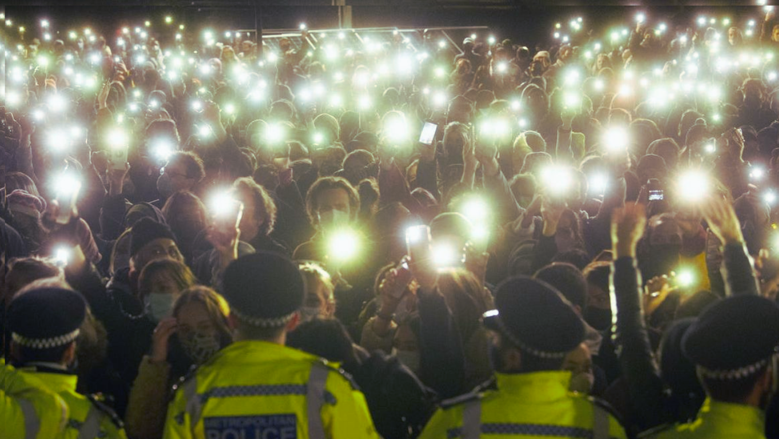

THE ANSWER IS US.
WE THE PEOPLE OURSELVES.

We are the ones who must work this out, not our compromised, ego-driven political class.

Only then will the decisions and policies we choose feel legitimate to us all.

For that to happen, we must rediscover our ability to speak openly and deeply listen to one another’s perspective, despite the depth of our differences.

To see our opponents as human. To allow them to change our perspective. To seek compromises we can all live with.

That is real democracy.

In these polarised times, it probably seems impossible.

We The People offers a practical mechanism to make it happen.

[CROWDS BUT IN ORDER; PEOPLE SITTING IN CIRCLE, BUT NOT TO CORPORATE OR TOO HIPPY; OTHER COUNTRIES’ PARLIAMENT BUILDINGS IN CIRCLE, CAN BE EMPTY OR AI – ASSEMBLIES LISTENING TO SOMEONE GIVING TESTIMONY; COURTROOM STYLE? – COULD HAVE SOUTH AFRICAN REFERENCE TO T&R TOO]

[Deck had this:
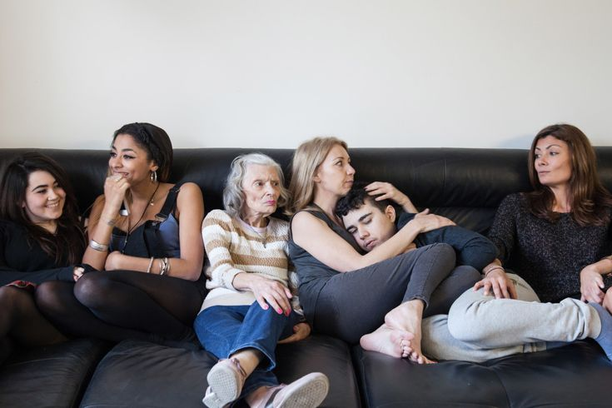

Another idea (although it’s quite white; we do need to think of representation in images/albeit in a balanced way):
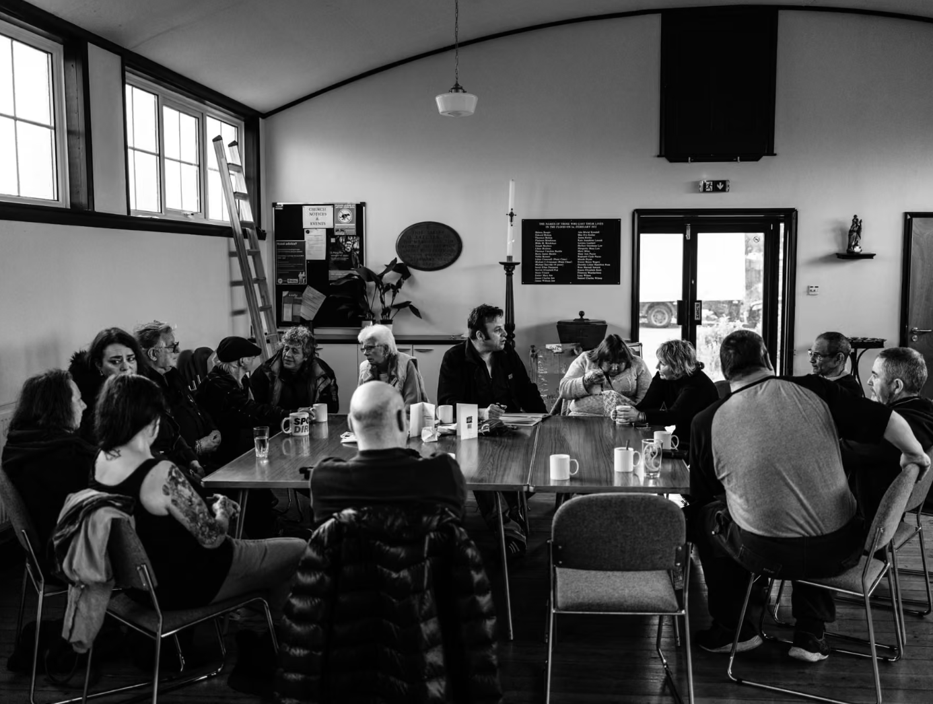

WE CALL IT
A COUNCIL OF THE PEOPLE

From two people to ten, from community level to nationwide, a Council of the People is a way for us to talk to each other again with honesty and respect, to find a way through our deep divides.

Whatever the scale, the principles are the same: everyone is welcome and every point of view can be spoken and heard, without fear of censure.

For smaller groups, we offer a clear step-by-step process, principles and resources to do it yourself.

In larger groups, we provide impartial facilitation to support the process, creating room for understanding, respect — even empathy.

(More details on the different models can be found in Part 3 – Be Part of It.)

TRUTH & RECONCILIATION

[We had a separate image for this in the deck – but might not need it]
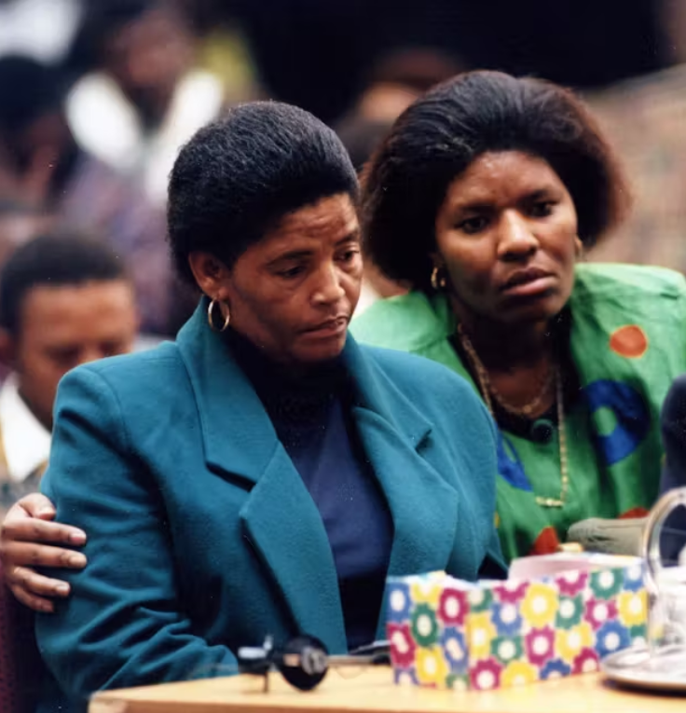

Whatever your perspective, in Council you will likely hear things you don't agree with, which might make you furious or upset. And that will be hard.

But this is the heart of the process, the leap we're asking everyone to make: if you want your story and your perspective to be honoured, you must honour others when it's their turn.

Through the rollout of our mechanism, we will seek to spark a movement of national reconnection and reconciliation, culminating in a major cultural event: a National Council of the People on Immigration.

The first time in which we the people ourselves will write our own policy on immigration, instead of politicians.

[IMAGES: ASSEMBLY IN IRELAND; OR FRANCE; OR ANCIENT FOLKMOOTS, ICELANDIC ALTHING]

From deck:
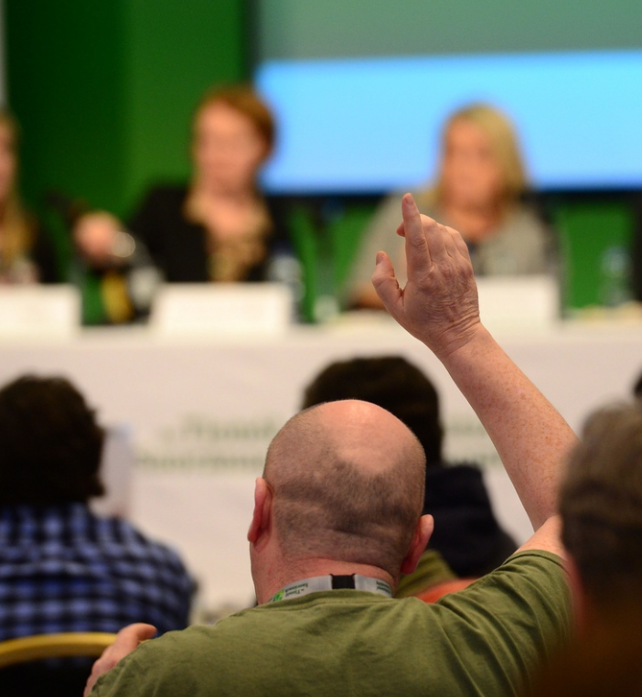

DRAWING ON NEW AND ANCIENT FOUNDATIONS

Councils of the People are inspired by a modern democratic model: a Citizens’ Assembly.

It is a 21st century version of an age-old democratic structure, with roots in ancient Greece and the moots once held on these islands a thousand years ago.

In simple terms a Citizens’ Assembly applies the principles of jury service to politics.

A group of 100 or more everyday people are selected by lottery to reflect the population as a whole by factors like class, age, gender, race etc.

They are given a difficult problem to face, like immigration. They listen to experts and witnesses from all sides of the debate and then talk among themselves to forge policy approaches that everyone can accept.

In the last decade, Assemblies have been held all over the world.

In Ireland, one helped people navigate the question of abortion. In France, on assisted dying. We even had one in the UK on climate change that led to rare agreement between left and right.

WHY IT WORKS

Crucially, Citizens’ Assemblies enshrine the idea that everyday people should make the decisions that affect our lives, not a political elite.

That free from the pressures to win votes, funding or influence, our decisions have greater legitimacy too.

Most importantly, that in the right circumstances, with impartial facilitation and expert witness testimony, we can dialogue with intelligence and civility and agree a more nuanced approach than any politician ever could.

WE START TO BELIEVE IN “US” AGAIN

[YOUNG PEOPLE, PARLIAMENT, IMAGES OF UNITY]

From deck:
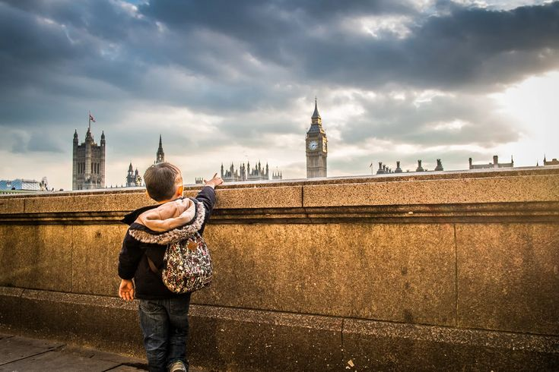
Another idea:
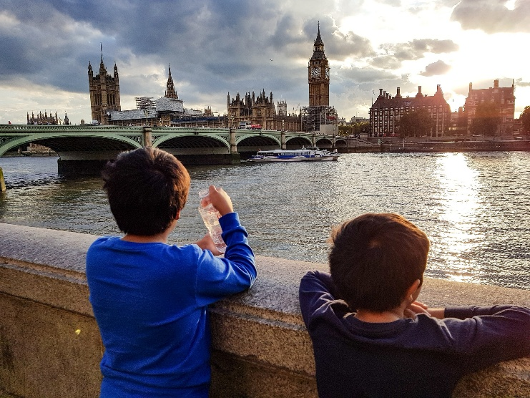

Of course, there will be hard compromises. Undoubtedly everyone will find some part hard to stomach.

Yet we believe it will lead to the first ever policy approach that most people would accept.

This is a practical path for us to stop being a collection of tribes and start becoming a people again, capable of forging a shared vision for our future.

If it works, we will know there is a powerful new way to do politics. One where we take the lead.

This is how our system could be transformed.

THIS IS HOW WE TURN THINGS AROUND

3. BE PART OF IT, MAIN PAGE
[We want to have 3 choices here, that correspond to the different levels of the movement.
When you hover over one, it expands as per the sections below.
YOU

YOUR
COMMUNITY

OUR
COUNTRY

SECTION I: YOU
There is so much we can do as individuals to bring We The People to life.
Just being kinder, more open and less confrontational would be a great start.
But we’d like to suggest something more specific.
[IMAGES – an anonymous pair of hands holding tea together]
Example:

Because even in these divided times, there is surely one thing left that we Brits can agree on…
Tea.

Could you talk over a 10-minute cup of tea with someone on the other side of the political divide?
Can you #AgreeOnTea?
Perhaps with your uncle who wants to stop the boats.
Your sister who wants to free Palestine.
Your butcher who votes Reform.
Your workmate who votes Green.
[IMAGES FOR THE GAME - Is there a way we can make this feel fun / gamified? Icons? Can it be a downloadable/shareable image? Like the back of a board game.
If this is too much of a design ask for you right now then we will think further]
Rules of the Game
The rules are simple: each person has 3 rounds of 90 seconds each to speak.
When one person speaks, the other must listen. No interruptions.
When it’s your turn to speak, you give your honest and heartfelt point of view.
When it’s your turn to listen, you really listen – rather than just thinking about what you’re going to say next.
Ideally, use an alarm for timings so that you’re free to engage with the other person, not your phone.
And don’t forget the golden rule: while this is all about speaking your mind, be sure to treat the other person in the way you would wish to be treated.
Pour the brew, milk and sugar. Start the timer and begin.
The T.E.A. Blueprint
The subject of this round of the game is immigration, the issue that most urgently threatens our collective life.
Many of us already have passionate perspectives on this issue, so you may want to dive straight in.
But we recommend following our T.E.A. blueprint:
Round 1: Time to check in.
How are you feeling, what’s on your mind or going on in your life right now?
Round 2: Express your point of view.
What is your personal point of view on immigration?
Round 3: Approach the bigger picture.
Think about us as a country. What do you think would be most helpful for us all in how we approach this issue?
The Last Minute
Use the last minute to reflect on the process:
How do you both feel about the conversation?
And where might it lead?
What Happens Next
[IMAGES - we thought perhaps fewer images in this section to keep it simple and comprehensible - but perhaps another image could come in here?
I had this one in the deck, but perhaps feels too much like a bar…]
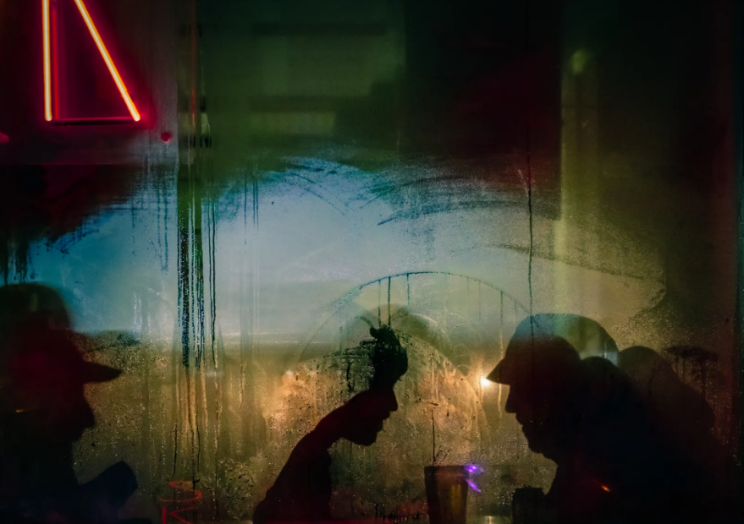

Of course, the most important thing is that the conversation happens at all. And if you want to keep it entirely private, that’s totally fine.
Or you could just share a photo of your two hands, your cups or your mugs, tagging #AgreeOnTea and #WeThePeopleGather.
Or go all the way and share audio or video of the whole conversation or just a snippet.
If people hear both of you #AgreeOnTea, it might inspire others to follow suit.
Perhaps create a wave of reconnection across the country.

[IMAGES: might be a bit cliche but perhaps something of the road ahead, a tiny figure setting out on a journey etc]
One possible example:
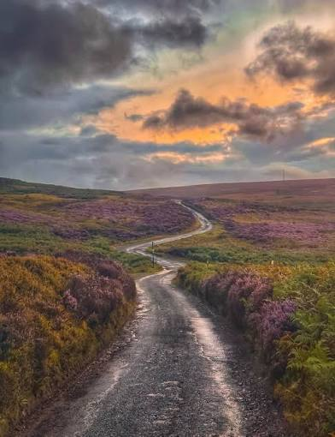
A First Step
If the journey to come back together is 10,000 miles, this might be our first step.
When we the people choose to talk and listen to each other with respect once more.
A moment to challenge the perception of insurmountable division.
A glimpse that a more united, hopeful future is possible.

SECTION II: YOUR COMMUNITY
[IMAGES - we could use whichever image we did not use in Section 2’s “Council of the People”.
Or look for other images of gatherings of people.
Some ideas:

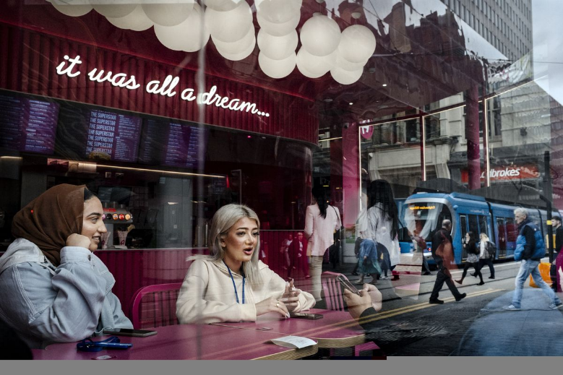
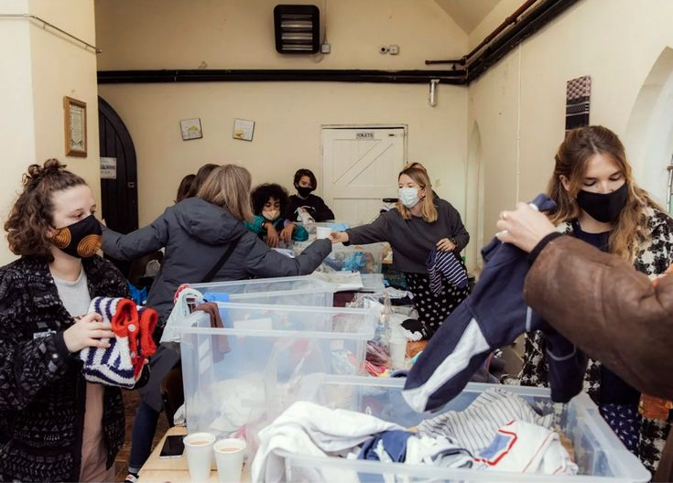
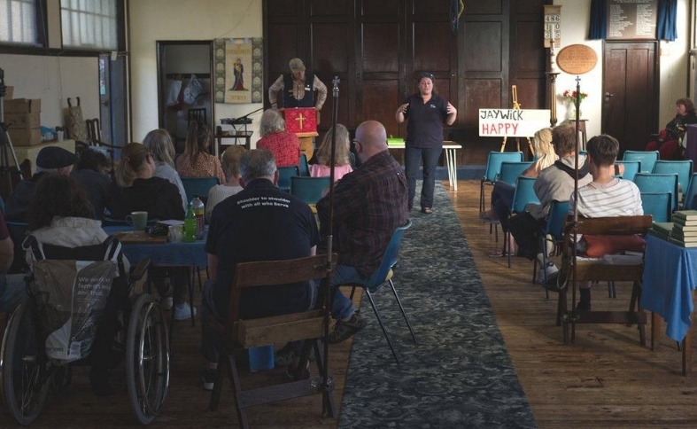
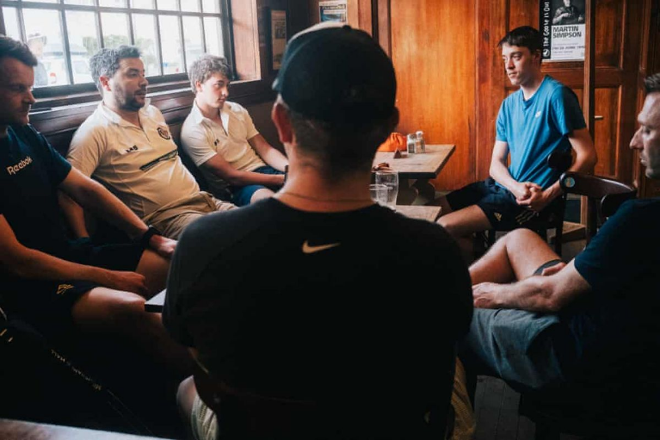

WE THE PEOPLE OF…
Dover. Brixton. Edinburgh. Piddington. York. Cardiff. Hastings — and more.

The issue of immigration has touched many of our communities, both for good and for ill.

The divisions we see in the country find their way into our day-to-day lives and the places we call home. Even our family tables.

So we offer two paths to hold a Council of the People for your community, whatever its size.

Download our toolkit

Access our free toolkit (coming soon) for a clear step-by-step process, principles and resources to hold a gathering yourself.

We can also connect you with a network of expert facilitators in your area, if required.

Let Us Help

Please get in touch if you would like our direct support in holding a Council of the People in your community.

We can provide bespoke guidance on setting up a Council and also offer impartial facilitation for the Council itself.

If we do not have capacity for our team to attend on the day, we will endeavour to connect you with a facilitator team in your area that can do the same job.

Though it is up to you to source an appropriate venue, provide refreshments and advertise, we offer our services at no cost.

The dream:
To inspire a wave of reconnection and reconciliation
in communities across the country.

Images here could include some kind of British street party (though perhaps too white)
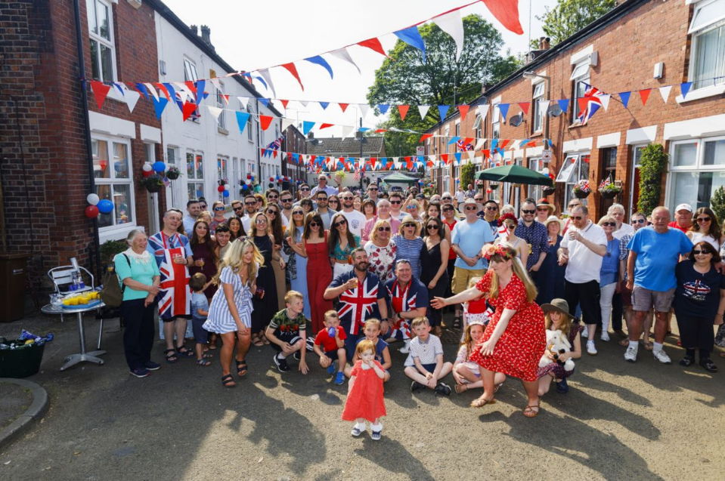
Or something like this celebratory picture of the evening applause during Covid:
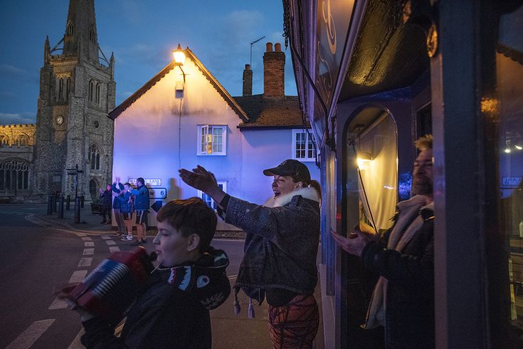

SECTION III: OUR COUNTRY

[IMAGES: I went for an example of a circular parliament building in the deck - some kind of circular space, conference hall, meeting room might work - but needs to feel like it’s national in scale]
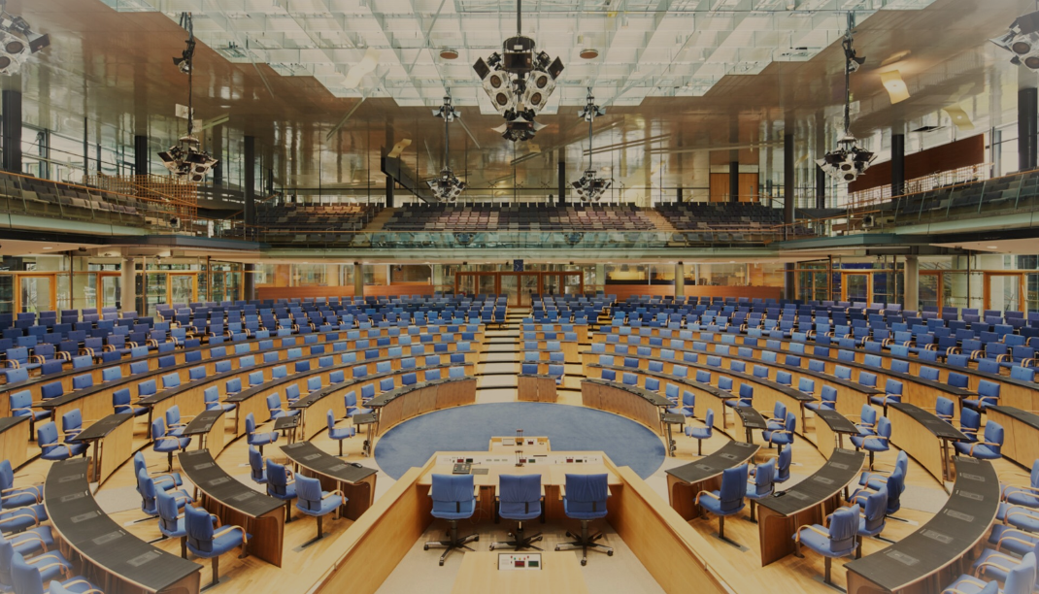

Starting with you, through your community, we hope that the wave of reconnection and reconciliation will culminate in a major cultural event: a National Council of the People on Immigration.
Using the Citizens’ Assembly approach (see Our Great Hope), we will select a group of 100 or more everyday people to discuss

HOW MIGHT WE APPROACH IMMIGRATION AS A COUNTRY?

Lasting for up to two weeks, the Council will hear testimony from experts on immigration as well as personal stories of those whose lives have been affected by the issue.

These could include positive stories of the beauty of British culture or contributions made by refugees. Or they could be negative stories of racist attacks or violence perpetrated by immigrants.

It will be a place where all sides can speak without fear of judgment. Where ghosts from the past can be faced. Where we can express anger, grief, even shed tears.

An opportunity for the communities of this island to share their stories at last, in search of a more united, hopeful future.

A MOMENT OF NATIONAL CULTURAL IMPACT

[IMAGES - want cool, iconic British cultural figures or moments. These will obvs be hard to license!
I went for Stormzy at Glastonbury:
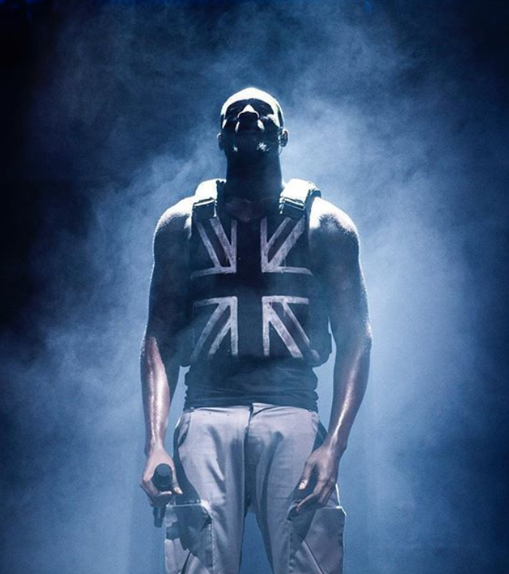

In that way, the national Council of the People aims to have a positive impact across our society.

To that end, we will aim to engage as many people as possible by making the Council exciting, emotional — even entertaining.

We will involve high profile cultural figures from across the arts, music, film & TV both to drive public awareness and of course share their perspectives too.

[IMAGES - this could be people on their phones in strange/classic British places, showing that people can follow the Council of the People wherever they are]
The image from deck:
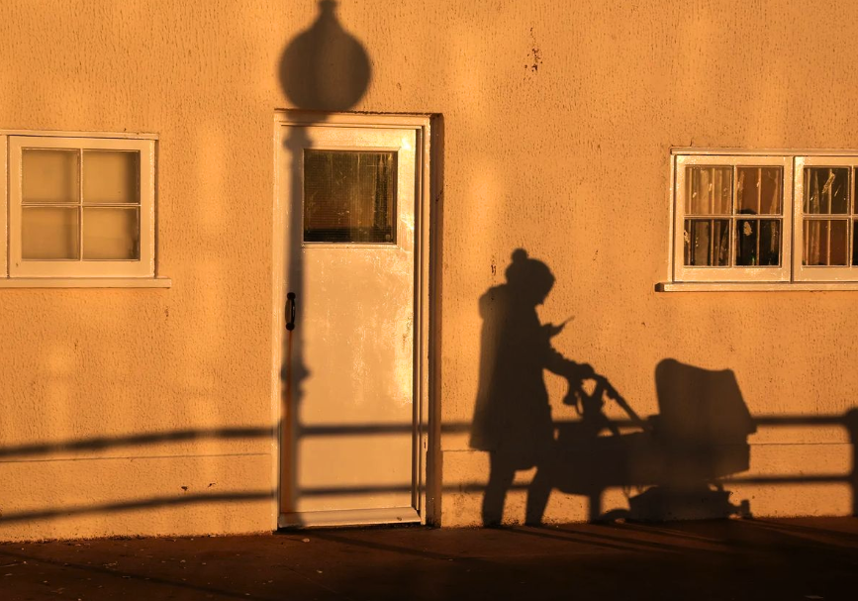

WITH THE PEOPLE

We will also create a broad media ecosystem for people to engage whoever and wherever they are in the country.
- Social as well as legacy media to reach every generation
- Newsworthy viral events
- Live streams of Council sessions
- Daily highlight shows on a range of platforms
- An app where users can follow proceedings, post comments and interact through polls on policy ideas
- A documentary to tell the Council's story
- A portal for people to submit their own stories building an archive of our national memory on immigration

[Could include another image here to show the site as a festival vibe kind of place - blurring out the namer of the fest though if we use this:
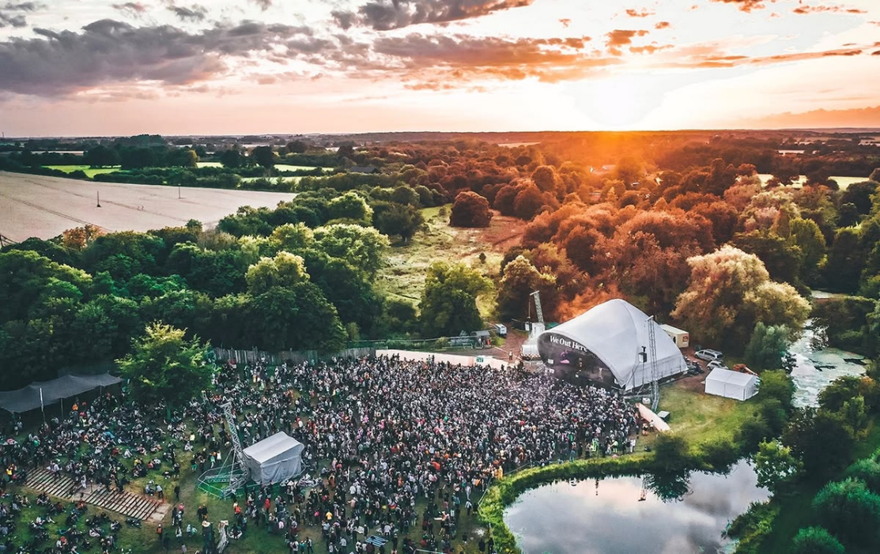

The site itself will be accessible with music, food, exhibitions and relevant events to draw audiences to attend in person.

[IMAGES - this is where we might repeat the image themes of the final section of Part 2 - YOUNG PEOPLE, PARLIAMENT, IMAGES OF UNITY]

The goal of it all: to show people that there is another way for our democracy to function, where their contributions are valued and counted, rather than ignored or overruled.

The prototype on which we can build a new political system fit for whatever the future may hold.

[IMAGES - this is where I included this very arty photo - a child looking into the great unknown.
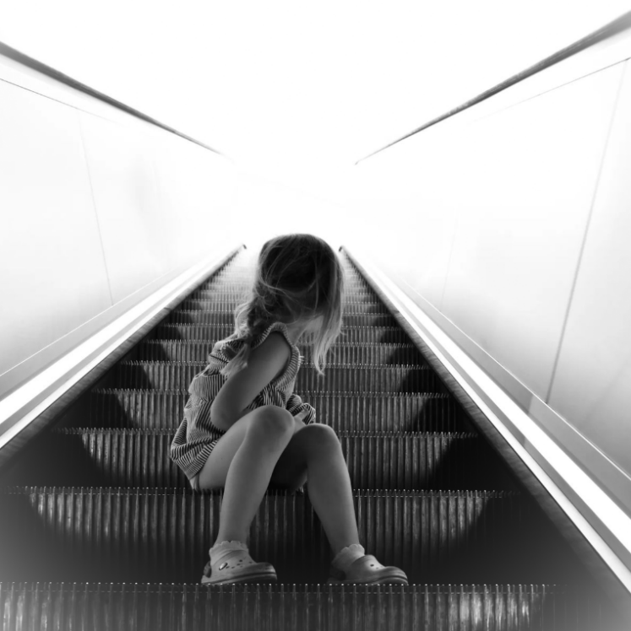

TO THE FUTURE, WITH HOPE

Immigration is only the start.

We will go on to apply our Councils of the People to other issues tearing us apart, from cost of living to taxation to the NHS, even to our international relationships or the regulation of AI.

While it may sound absurdly ambitious, we believe We The People speaks to a gap in the market – a message of hope, unity and empowerment that will strike a chord with millions across the country.

If that happens, anything is possible.

And with each step, we build a vision of what we want for our future, written by us – a People’s Manifesto – while growing a Movement with the political force to make it happen.

We will make this a better country. More peaceful, more united, more democratic. Fit for the challenges of the 21st century. A country our children will be glad to inherit.

[IMAGES - we want to end with something that feels triumphal, united, lots of British people together like at one of our national celebrations.
From the deck:
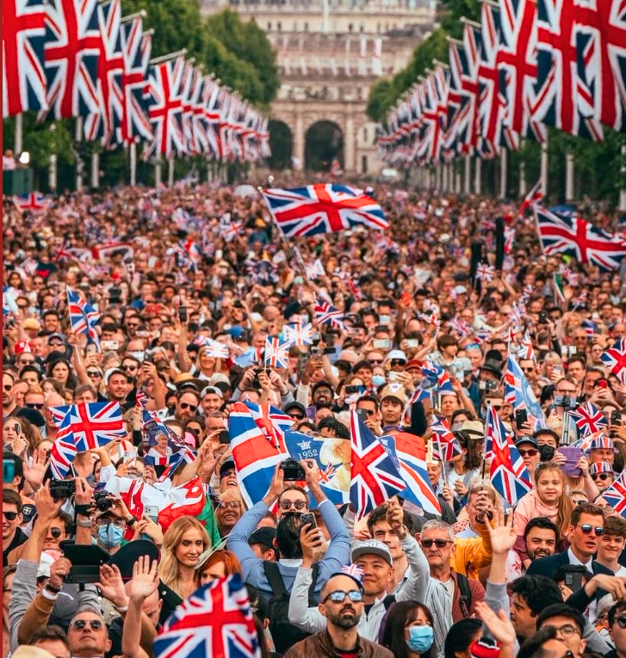

4. I’M IN, main page
[We are imaging this button would be a fixed “Footer” across the site – and carry you through the sign-up page]

Thank you for your interest in taking an active part in our We The People movement.

The challenges ahead may be significant, but nothing is impossible if we all work together.

There are many opportunities to actively contribute: organising, outreach, fundraising or even just spreading the word in your circles that a new approach for our country and our future exists.

We know you will have questions, ideas, doubts. We want to hear them all.

Our only request is that in signing below you pledge to lay your personal political affiliations aside – just for now – in service to the objectives of this movement.

OVERCOME OUR DIVISION
RECLAIM OUR POWER
TRANSFORM OUR SYSTEM

Sign up below or email hello@wethepeoplegather.com.

